The doc is prepared for factory operators for how to safely use manufacturing tool.

# PC requirement

* **CPU**: Intel E3400 or higher, Frequency: 2GHz+
* **Memory**: 1GB+
* **OS**: Windows XP/Windows 7 version. Administration account is necessary to install driver (For i.mx35/51/53).
* **Desktop is a must.**
* **USB2.0 root hub is a must**
* **No USB hub allowed.**

# Operation flow

## For i.mx35/51/53 platform, below steps must be followed.

**Warning： Below steps must be followed, or you may find your PC gets blue screen.**

1. Open Mfgtool.exe on PC side.
2. Connect products to PC through USB cable. Don’t power on any of them.
3. Power on all products at the same time. To do this, please make sure you use a power socket with On/Off switch for power supply.

Warning: Don’t be idle after power on, go to next step ASAP, or you may get blue screen on your PC.

1. Click start button (the green block in below snapshot) in Mfgtool’s panel.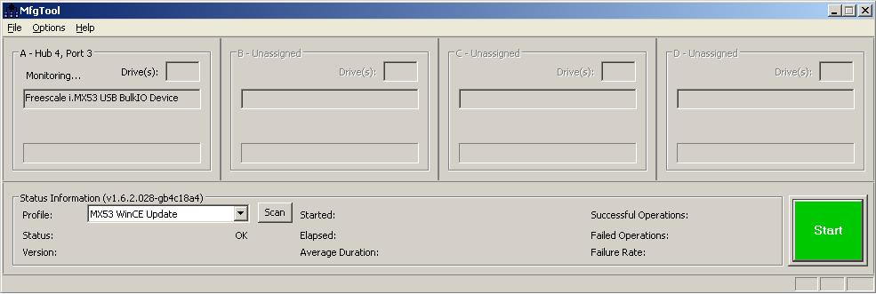
2. Wait till all products’ burning work finished. You can find the progress bar turns to green.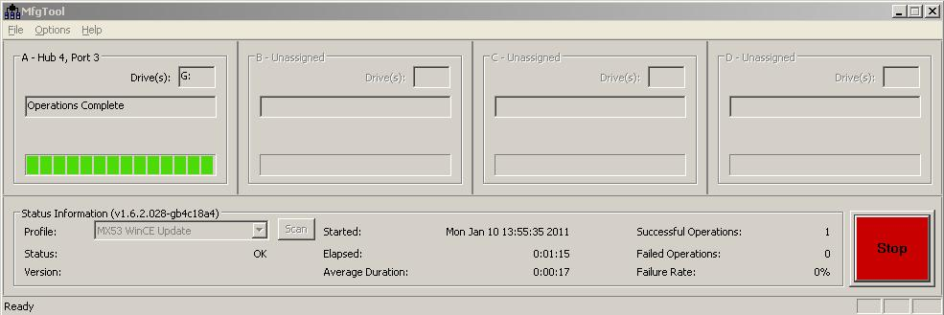
3. Click Stop button.
4. Powered off all products and disconnect them from PC.
5. Go to Step 2 for next round.

## For other platforms, below step should be followed:

1. Open Mfgtool.exe on PC side.
2. Connect products to PC through USB cable and power on them.
3. Click start button (the green block in below snapshot) in Mfgtool’s panel.
4. Wait till all products’ burning work finished. You can find the progress bar turns to green.
5. Powered off all products and disconnect them from PC.
6. Connect next round products to PC through USB cable and power on them.
7. Go to Step 4.

# Why are the requirements necessary

* Need enough running speed since there are a lot of timeout settings in manufacturing tool.
* To guarantee USB current supply since multiple devices are simultaneously operated, which need very large current from USB root hub.